NAGIOS
Alternates: SPLUNK, KIBANA, PROMETHEUS, ELK, SENSU, LIBRATO
- It is an open-source software for continuous monitoring of systems, networks an Infrastructure.
- It runs plugin stored on server which is connected with a host or another server on your network or the internet.
- In case of any failures Nagios alerts about issue so that technical team can perform recovery process immediately.

HISTORY
- In 1999, Ethan Galstad developed it as a part of Netsaint distribution.
- 2000, he renames the project to Nagios because of trademark issues with Netsaint.
- In 2009 Nagios released it first commercial version Nagios X1.
- In 2012 Nagios renamed as Nagios Core.
- It uses 5666, 5667 and 5668 to monitor its clients.

Why Nagios
- Detect all types of networks, or server issues.
- Helps to find out root cause of problem which allow you to get permanent solution.
- Reduce Downtime.
- Active monitoring of entire infrastructure.
- Allow you to monitor and troubleshoot server performance issues.
- Automatically fix updates.

FEATURES
- Old and latest.
- Good log and database system.
- Informative and attractive web interface.
- Automatically sends alerts if condition changes.
- Helps you to detect network or errors or server crashes.
- You can monitor the entire business process and IT infrastructure with single pass.
- Monitor network services like HTTP, SMTP, SNMP, FTP, SSH, POP, DNS, LDAP, IPMI, etc.

PHASES OF MONITORING
- DEFINE: Develop a monitoring Strategy.
- ESTABLISH: How frequently you are going to monitor it.
- Implement.
- Analyze data and report finding.
- Respond.
- Renew and Update.

NAGIOS ARCHITECTURE
- It is a client-server Architecture usually on a network, a Nagios server is running on a host and plugins are running on all the remote host which should you monitor.

HOW IT WORKS
- Mention all the details in configuration files.
- Daemon red these details what data is to be collected.
- Daemon use NRPE plug-in to collect data from nodes and store in its own database.
- Finally shows everything.
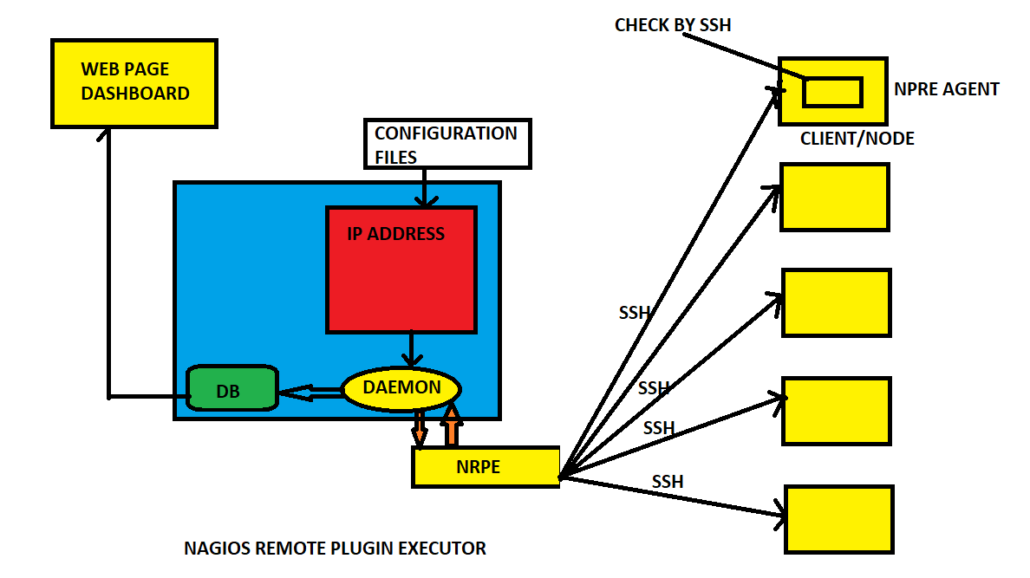
PRE REQUISTES
- HTTPD : Browser
- PHP : Dashboard
- GCC & GD : Compiler
- MAKEFILE : To build
- PERL : Script
- Main config file : /usr/local/nagios/etc/nagios.cfg
- All monitoring things are called as service.
- EX: 5 Servers -- > 4 check each you have to monitor -- > 5*4=20 Services.

DASHBOARD OVERVIEW
In dash board you can see
- HOST --- > Down
Unreachable
Up
Recovery
None

- SERVICES --- > Warning
Unknown
Critical
Recovery
Pending
- To reach the Nagios Ip/nagios/
INSTALLATION OF NAGIOS
- To start Nagios core installation, you must have your EC2 instance and run and have already configured SSH access to the instance.
- Execute the commands one by one now

- sudo su
- Yum install httpd php
- Yum install gcc glibc glibc-common
- Yum install gd gd-devel
- useradd nagios
- passwd nagios
- groupadd nagiosgrp
- usermod -a -G nagiosgrp nagios
- usermod -a -G nagiosgrp apache
- mkdir ~/downloads
- cd ~/downloads
- get https://assets.nagios.com/downloads/nagioscore/releases/nagios-4.4.5.tar.gz
- wget https://nagios-plugins.org/download/nagios-plugins-2.2.1.tar.gz
- tar zxvf nagios-4.4.5.tar.gz (x=extract, v=verbros, f=forcefully)
- cd nagios-4.4.5
- ./configure --with-command-group=ngroup
- make all
- make install
- make install-init
- make install-config
- make install-commandmode
- vim /usr/local/nagios/etc/objects/contacts.cfg (can configure user user details here)
- make install-webconf
- htpasswd -c /usr/local/nagios/etc/htpasswd.users nagiosadmin
- service httpd restart
- cd ~/downloads tar zxvf nagios-plugins-2.2.1.tar.gz
- ./configure --with-nagios-user=nagios --with-nagios-group=nagios
- make & make install
- systemctl enable nagios.service
- /usr/local/nagios/bin/nagios -v /usr/local/nagios/etc/nagios.cfg
- Now it wil give total warnings and error is zero. It is pre flight check.
- systemctl restart nagios s
- systemctl status nagios
- Service httpd restart
- Copy your public ipv4 and paste it on browser like this (ipv4/nagios/)
- It will ask username & password then you will see the UI.
